2. Write a simple two players dice game. Each player will roll the dice twice and the player with the highest score wins the game. You need to follow the special rules as stated below.

|  |  |
| --- | --- |
| **Rules** | **Score** |
| If first and second dice value are 6 | No score but can roll the dice twice. |
| If first and second dice value are 1 | No score but multiply the existing score by 2. |
| If first and second dice value are both odd number and not both 1. | No score and -5 from the existing score |

1. **Problem Description**

The question requests to create a multi round two-player dice game, each player will roll the dice twice each round and the player with the highest score wins. In this game, the players will determine and input how many rounds their game will be. the score of each round will equals to the sum of value of dice which the players diced.

However, there are special rules for the game. After the player roll the two dices, the program will need to check if the outcome of the two dice equivalent to any of the specific outcome, which are both dice value are 6, both dice value are 1, and both dice value are odd and are not 1.

After all rounds have completed, the program will compare final cumulative score of both player, and displays the player with higher score as the winner of the game.

1. **Solution**

In the program, we create the essential variables: two player’s accumulative score, two random numbers(randomly generated using random method) as the two dice, and the round of the game. Before the game starts, user will be prompted to input total rounds they will play for their gamer. In the game, two dices’ outcome can be obtained by generating two random integers between 1 - 6. A while-loop will be created to repeat the process, with ‘round of the game’ be the counter, the condition controlling the loop. The loop will break after all rounds are completed.

After the game starts and the dices are rolled, by using if-else statements, the program will check if the two dice is equivalent to the specific outcome:

1. If both dice rolled are 6, then the loop will ‘continue’, which skips all the following statements and counter update, re-execute the current round and re-roll the dice.
2. If both dice rolled are 1, then the program will not add the dices’ value to the player’s cumulative score, but instead double the current cumulative score of the player.
3. If both dice rolled are odd number and are not 1, the program will not add the dices’ value to the player’s cumulative score, but instead deduct 5 marks from the player’s cumulative score.

When the while-loop reach the total round of the game and had completed all rounds, the program will then output both players’ cumulative score. Using if-else statements to compare both players’ cumulative score, the program will output the player with the higher score as the player. If both players have the same cumulative score, program will output that the game is a draw.

**Pseudocode**

start

declare int scorePlayer1, scorePlayer2, dice1, dice2, playerTurn, round

initialize scorePlayer1 = 0, scorePlayer2 = 0, playerTurn = 1

Create object Scanner and Random

Request user to input rounds to play

Store number of rounds in round

while(true)

dice1 = random number between 1-6

dice2 = random number between 1-6

if(playerTurn is odd number)

output “Player 1’s turn” and dice1 and dice2

if(dice1 and dice 2 == 6)

output “Player1’s both dice value are 6, roll again

skips all following statements and re-roll the dice

else if(dice1 and dice2 == 1)

scoreplayer1 = scorePlayer1 * 2

else if(dice1 and dice2 are odd and are not 1)

scorePlayer1 = scorePlayer1 – 5

else

scorePlayer1 = dice1 + dice2

end if

else if(playerTurn is even number)

output “Player 2’s turn” and dice1 and dice2

if(dice1 and dice 2 == 6)

output “Player2’s both dice value are 6, roll again”

skips all following statements and re-roll the dice

else if(dice1 and dice2 == 1)

scoreplayer2 = scorePlayer2 * 2

else if(dice1 and dice2 are odd and are not 1)

scorePlayer2 = scorePlayer2 – 5

else

scorePlayer2 = dice1 + dice2

end if

if(playerTurn = round * 2)

break the while-loop

end if

end while-loop

output scorePlayer1

output scorePlayer2

If(scorePlayer1 > scorePLayer2)

output “Player 1 wins!”

else if (scorePlayer1 < scorePLayer2)

output “Player 2 wins!”

else

output “It’s a draw!”

end if

stop

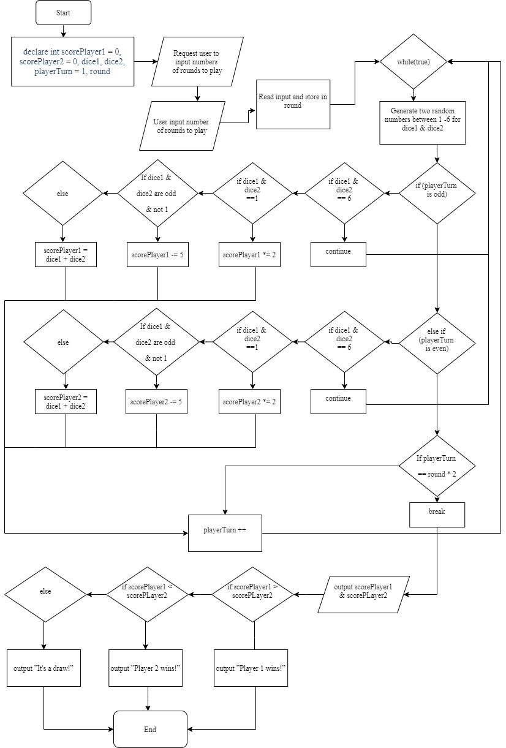**Flowchart**